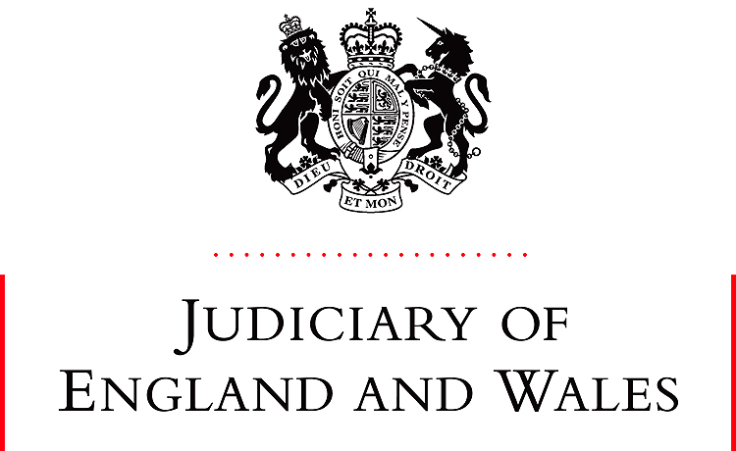

11 February 2021
SUMMARY

HRH The Duchess of Sussex v Associated Newspapers Ltd
[2021] EWHC 273 (Ch)
Mr Justice Warby
- Following a hearing on 19-20 January 2021, the court gives judgment on the claimant’s application for orders striking out part of the Defence and entering summary judgment in her favour on her claims for misuse of private information and copyright infringement.

The action and the application
- The claimant is the actor Meghan Markle, also known as the Duchess of Sussex and wife of HRH Prince Henry of Wales, The Duke of Sussex, whom she married on 19 May 2018. The relationship between the claimant and her father, Thomas Markle, was difficult at the time. On 27 August 2018, she sent him a five-page letter (“the Letter”). This action arises from the later reproduction of large parts of the Letter in articles published by the defendant in the Mail on Sunday and MailOnline (“the Mail Articles”). [1]
- The existence of the Letter first became public on 6 February 2019 when it was mentioned in an article in the US magazine People (“the People Article”). Mr Markle then provided the defendant with the Letter. On 9 February 2019, the defendant published the Mail Articles under headlines, the gist of which is conveyed by one: “Revealed: the letter showing true tragedy of Meghan’s rift with a father she says has ‘broken her heart into a million pieces’”.[2] The Mail Articles drew extensively on the words and information in the Letter.
- In this action the claimant alleges that this involved misuse of her private information, breach of her data protection rights, and infringement of her copyright in the Letter and of a draft of the Letter she created on her phone (the “Electronic Draft”). [3-5].
- The defendant denies that the claimant had any reasonable expectation of privacy in the contents of the Letter, alternatively it says any such expectation is outweighed by the need to protect the rights of her father and the public at large [6]. The defendant denies that the Letter is an original literary work in which the claimant owns the copyright, alternatively it relies on defences of fair dealing, public interest, and freedom of expression. Its case includes reliance on allegations that the claimant disclosed information about the Letter to the authors of a biography of the Duke and Duchess published in mid-2020, called Finding Freedom (“the Book”) [7].
- The claimant now applies for summary judgment on the privacy and copyright claims [9]. Her case is that the defence discloses no reasonable grounds for defending the privacy claim, and the defendant has no realistic prospect of successfully defending either claim at a trial. The hearing is not concerned with the data protection claim.
- The Court identifies the principles that govern striking out and summary judgment [10-18], the timing of the application, and the evidence relied on by each side [19-27]. The judgment then addresses the privacy and copyright claims in turn.

Misuse of private information
- The judgment identifies the essential legal principles [28-32] and the issues for decision [33-36]. The essential facts are then set out, including the father-daughter relationship at the relevant times [38-43], the Letter [44-45], Mr Markle’s reply [46], the People Article [47-51], dealings between Mr Markle and the defendant [52], the defendant’s editorial processes [53-54], the fact the defendant made no contact with the claimant [55], and the contents of the Mail Articles, which are set out or described in some detail: [56-60]. Some details of the legal proceedings are mentioned [61-62]. The defendant’s case on the Book is summarised, and key passages are set out [63].
- The merits of the case are then considered in detail [64-126]. Applying the two-stage test required by the law the Court concludes at [127] that:
- The claimant had a reasonable expectation that the contents of the Letter would remain private. The Mail Articles interfered with that reasonable expectation.
- The only tenable justification for any such interference was to correct some inaccuracies about the Letter contained in the People Article. On an objective review of the Articles in the light of the surrounding circumstances, the inescapable conclusion is that, save to a very limited extent, the disclosures made were not a necessary or proportionate means of serving that purpose. For the most part they did not serve that purpose at all. Taken as a whole the disclosures were manifestly excessive and hence unlawful. There is no prospect that a different judgment would be reached after a trial. The interference with freedom of expression which those conclusions represent is a necessary and proportionate means of pursuing the legitimate aim of protecting the claimant’s privacy.
- The limited exception referred to is that it was legitimate for Mr Markle and the defendant to use a part of the Letter to rebut a false suggestion in the People Article that the Letter represented some form of “olive branch” from the claimant to Mr Markle, but it was neither necessary nor proportionate for the Mail Articles to disclose any of the rest of the information in the Letter [124].
- The Court sees no useful purpose in striking out any of the Defence. Parts of it might be relevant to damages, and the work involved in filleting would be disproportionate to the gains. But there is no good reason not to enter summary judgment on liability; there are compelling reasons not to allow this aspect of the case to go to trial [128].

Infringement of copyright
- The claimant limits her case to the Electronic Draft. The judgment summarises the essential legal principles [129-133]. It identifies the issues [134-137], which are then addressed [138-167].
- The law on “originality” is set out [138-142]. The defendant’s case on the issue is summarised [143-144]. The Court concludes there is no basis in law or fact for that case [144-147]. It is satisfied that the Electronic Draft is and would inevitably be held to be the product of intellectual creativity sufficient to render it original in the relevant sense and to confer copyright on its author or authors [148].
- The Court finds for the claimant on infringement. Quantitatively, the Mail Articles copied a substantial part of the work (some 585 words of the total of 1,250) [149]. It is undeniable that they reproduced a substantial part in qualitative terms, and in the sense that they reproduced a substantial part of “that which is the author’s own intellectual creation” [15o-151].
- The Court’s analysis for the purposes of stage two of the privacy claim leads to the conclusion that the defence of fair dealing for reporting current events could not succeed [152-155].
- This is not one of those rare cases where freedom of expression trumps copyright. There is no basis on which the court could conclude that, although the copying was not fair dealing, the public interest required the copyright to be overridden [156-157].
- The Court is persuaded, however, that there should be a trial limited to issues relating to the ownership of copyright. The defence argues that a trial might show that the works are works of joint authorship or that there are several copyrights with different ownership. It relies on admissions by the claimant, hearsay evidence, and a solicitors’ letter, to suggest that the involvement of staff on the Kensington Palace communications team (“the Palace Four”) may have generated a copyright that does not belong exclusively to the claimant and may be Crown copyright [159-162]. The Court regards the defendant’s factual and legal case as occupying “the shadowland between improbability and unreality” [165]. It is “not easy to identify a useful litigious purpose” in a trial “the substantive effect of which would be, at best, to whittle down the remedies” [166]. But proportionality is not the criterion, the case cannot be described as fanciful, and these issues must go forward to a trial [167-168].

Disposal
- There will be summary judgment for the claimant on the claim for misuse of private information, and on the other issues in the copyright claim. A hearing to decide matters consequential on this judgment, and directions for the next steps is fixed for 2 March 2021.
NOTE: This summary is provided to help in understanding the Court’s decision. It does not form part of the reasons for the decision. The full judgment of the Court is the only authoritative document. Judgments are public documents and are available at: https://www.bailii.org/.

Paragraph numbers in bold are those assigned in the judgment.

